Model {

x ~ dbin(p,n)

p ~ dbeta(2,2)

}

list(n=100,x=50)

list(p=0.5)

学籍番号、ベータ分布のパラメータ、総試行回数、表が出た回数

1210132, 5, 5, 300, 147



**node mean sd MC error 2.5% median 97.5% start sample**

p 0.4904 0.0284 2.043E-4 0.435 0.4905 0.5462 1001 20000

1210126, 2.5, 4.5, 300, 129



**node mean sd MC error 2.5% median 97.5% start sample**

p 0.4283 0.02808 1.866E-4 0.3733 0.4282 0.4834 21001 20000

1210134, 3.5, 3.5, 300, 126

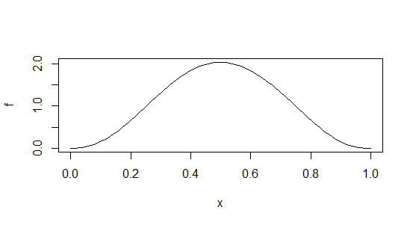

**node mean sd MC error 2.5% median 97.5% start sample**

p 0.4216 0.02818 2.025E-4 0.3671 0.4214 0.4771 2001 20000

1210129, 2.5, 3, 300, 141



**node mean sd MC error 2.5% median 97.5% start sample**

p 0.47 0.02865 2.02E-4 0.4143 0.4698 0.5262 1001 20000

1210128, 2.5, 4, 300, 138

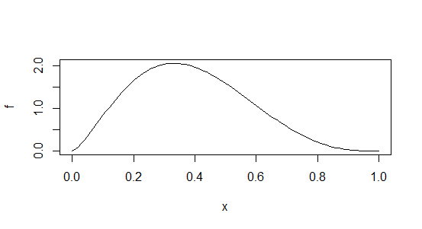

**node mean sd MC error 2.5% median 97.5% start sample**

p 0.4585 0.02844 2.022E-4 0.4029 0.4584 0.514 1001 20000

1210137, 9, 8, 300, 133



**node mean sd MC error 2.5% median 97.5% start sample**

p 0.4479 0.0279 2.035E-4 0.3936 0.4477 0.5027 1001 20000

1210135, 3, 5, 300, 140



**node mean sd MC error 2.5% median 97.5% start sample**

p 0.4644 0.02845 2.024E-4 0.4087 0.4642 0.5199 1001 20000

1210125, 2.5, 5, 300, 126



**node mean sd MC error 2.5% median 97.5% start sample**

p 0.4177 0.0281 1.994E-4 0.3633 0.4174 0.4733 1001 20000